1)Create Route53 hosted zone and MAP the domain with CDN.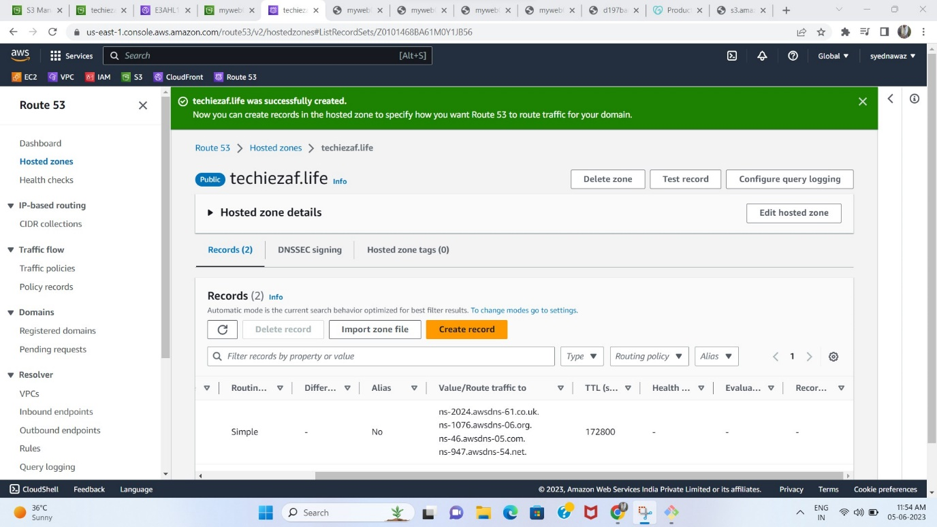

2) Deploy static website in s3.

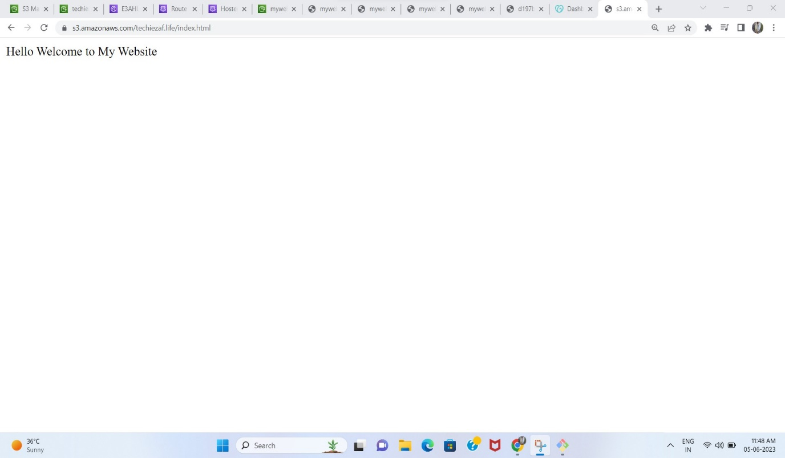

3)Create CDN and attach one SSL certificate.

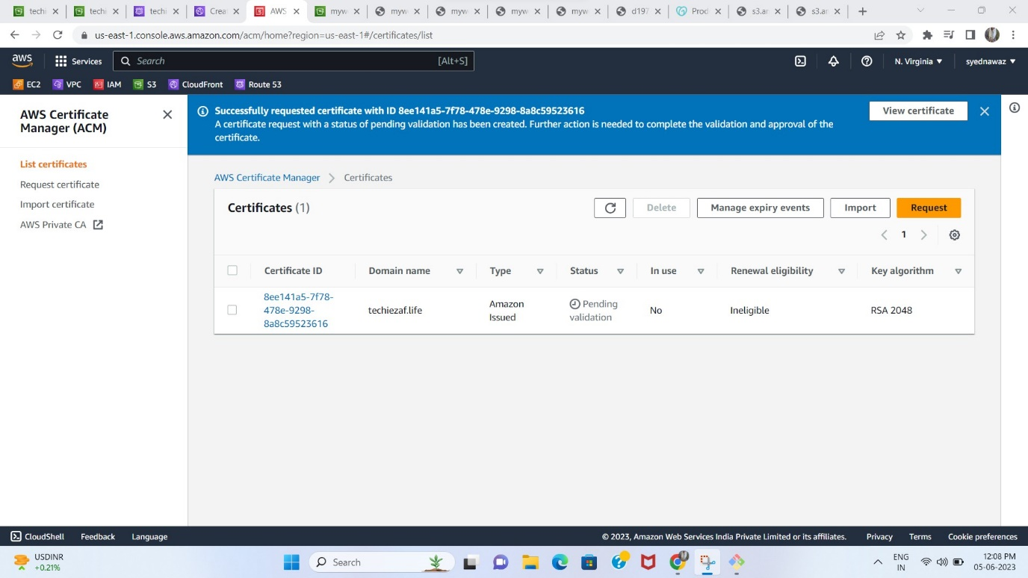

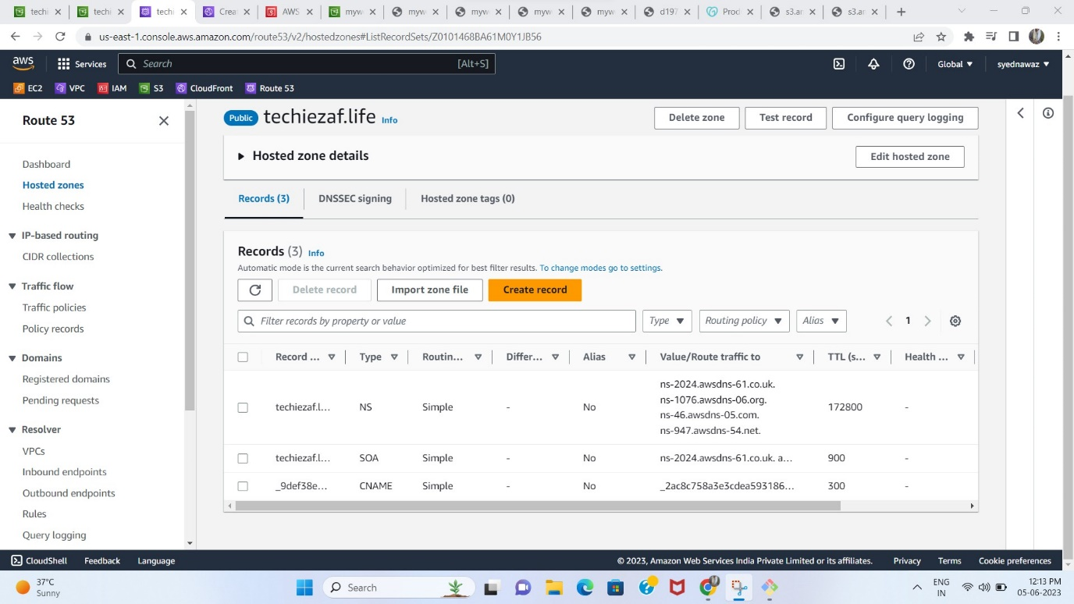

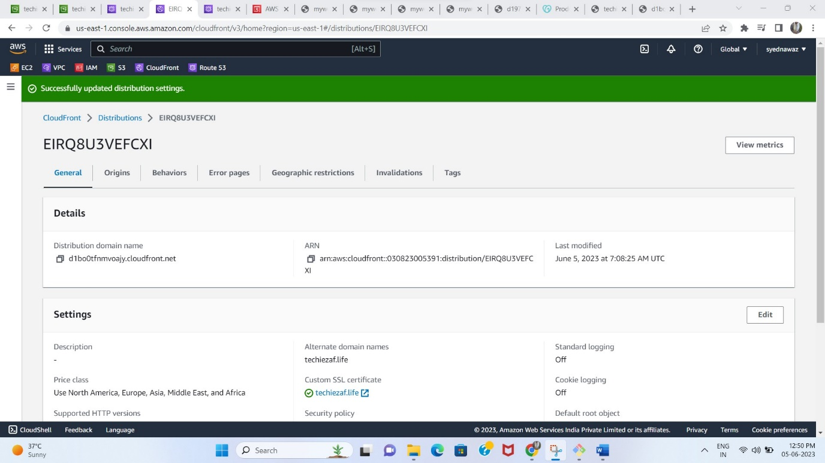

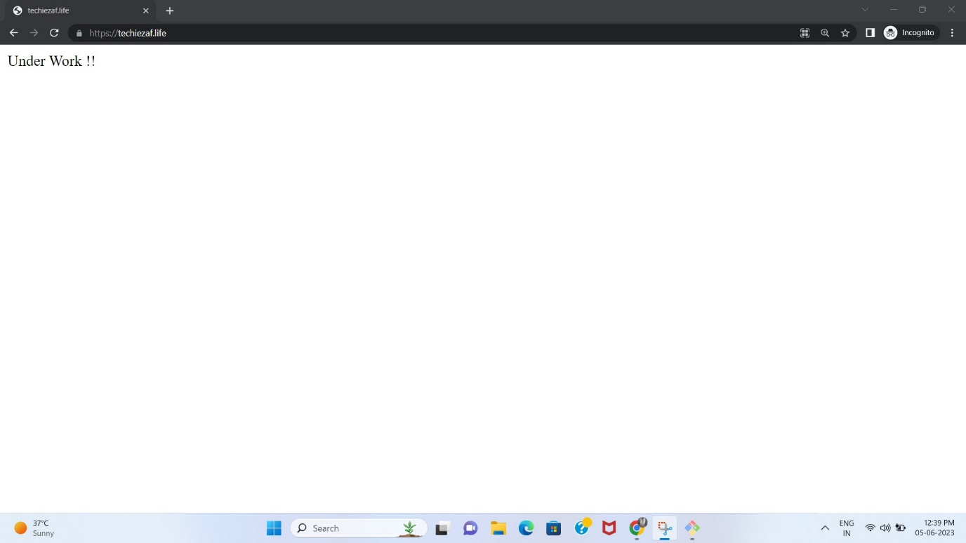

4)Update the index.html in s3 bucket and the updated file should be accessible by using domain name.

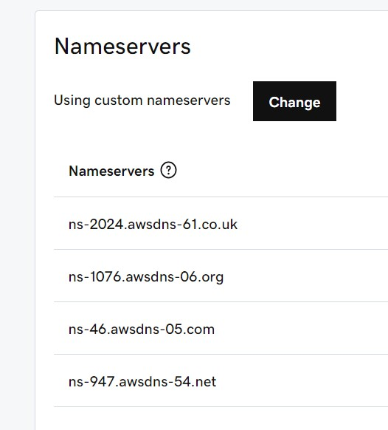

5) Share the Domain name in slack to test the connectivity.

<https://techiezaf.life>

6)Configure VPC peering in cross regions.(Need to do this again)

